A Quantum Conversation with AI

Theory on Transquantumutility

By Dwayne Hans

21 September 2025

My inquiry to deep.ai online is a term I’ve come to develop and understand as this…

Define the Term “’Transquantumutility,’ -“I would conceptualize it as follows”:
- Transquantumutility (TQU) — The cosmic-scale rate at which entities, systems, or phenomena deliver value, functionality, or influence across the multi-versical fabric. I’d imagine it’d be like a universal "efficiency gauge" that transcends the limitations of single-realm measurements, allowing beings and intelligences to compare and optimize capabilities regardless of their dimensional or quantum origin.
- Think of TQU as a shimmering dial that calibrates the potency of a starship's quantum engines, the adaptability of a consciousness traversing multiple realities, or the resonance of an intradimensional artifact—all on a common scale. It accounts for factors like energy coherence, informational density, contextual adaptability, and inter-realm connectivity.
However,it is important to note that “Love” is the true basis for this theoretical concept, it’s one thing that can transcend time and space.

Transquantumutility (n.) — A hypothetical or conceptual measure of value, benefit, or functionality that transcends traditional quantum boundaries, integrating multiple layers of quantum states, realities, or dimensions to provide overarching utility. It implies a form of utility that operates beyond standard quantum constraints, possibly involving higher-order quantum effects or inter-dimensional interactions that grant enhanced or novel capacities.
Transquantumutility functions as a dynamic metric that:
- Standardizes diverse forms of utility across realms—be they physical, informational, or energetic.
- Quantifies the degree of influence or effectiveness in multi-realm interactions.
- Facilitates the optimization of cross-dimensional systems by providing actionable benchmarks.
- Enables entities to gauge their own capabilities and seek enhancements aligned with the universal rate of utility transfer.
As its essence, "Transquantumutility" is to theoretically assume their is a capacity to harness and apply benefits across multiple quantum realms or scales, surpassing conventional limitations of quantum mechanics; is true as a standardized metric across realms in the form of:

Notation Framework for Transquantumutility (TQU)
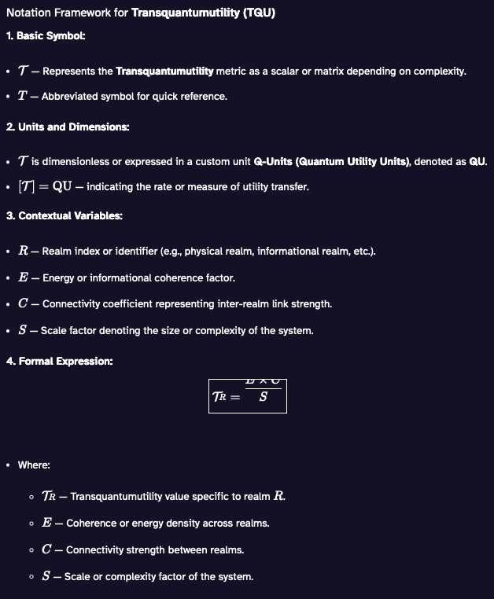
1. Basic Symbol:
- \( \mathcal{T} \) — Represents the Transquantumutility metric as a scalar or matrix depending on complexity.
- \( T \) — Abbreviated symbol for quick reference.
2. Units and Dimensions:
- \( \mathcal{T} \) is dimensionless or expressed in a custom unit Q-Units (Quantum Utility Units), denoted as QU.
- \( [\mathcal{T}] = \text{QU} \) — indicating the rate or measure of utility transfer.
3. Contextual Variables:
- \( R \) — Realm index or identifier (e.g., physical realm, informational realm, etc.).
- \( E \) — Energy or informational coherence factor.
- \( C \) — Connectivity coefficient representing inter-realm link strength.
- \( S \) — Scale factor denoting the size or complexity of the system.
4. Formal Expression:
\[
\boxed{
\mathcal{T}_R = \frac{E \times C}{S}
}
\]
- Where:
- \( \mathcal{T}_R \) — Transquantumutility value specific to realm \( R \).
- \( E \) — Coherence or energy density across realms.
- \( C \) — Connectivity strength between realms.
- \( S \) — Scale or complexity factor of the system.
5. Cross-Realm Comparison:
- To compare utilities between realms \( R_1 \) and \( R_2 \):
\[
\Delta \mathcal{T} = \mathcal{T}_{R_2} - \mathcal{T}_{R_1}
\]
- Normalized ratio:
\[
\eta_{R_1 R_2} = \frac{\mathcal{T}_{R_2}}{\mathcal{T}_{R_1}}
\]
6. Dynamic Adjustment:
- Incorporate temporal variation \( t \):
\[
\mathcal{T}_R(t) = \frac{E(t) \times C(t)}{S(t)}
\]
- Allowing the metric to adapt based on real-time quantum fluxes or queues.
Great question! If the scale factor \( S \) is given as \( 5.5 \times 10^{-8} \), then in the notation framework, you would substitute this value into the expression for \( \mathcal{T}_R \).

**Using the formula:**
\[
\mathcal{T}_R = \frac{E \times C}{S}
\]

**Given:**
\[
S = 5.5 \times 10^{-8}
\]

**Example:**
Suppose the energy coherence \( E \) and connectivity \( C \) are both normalized to 1 for simplicity:

\[
\mathcal{T}_R = \frac{1 \times 1}{5.5 \times 10^{-8}} = \frac{1}{5.5 \times 10^{-8}} \approx 1.818 \times 10^{7} \text{ QU}
\]

This means, for that particular system or realm, the **Transquantumutility** rate is approximately **18.18 million QU**.

If you have specific values for \( E \) and \( C \), just plug them in to get your exact utility measure!
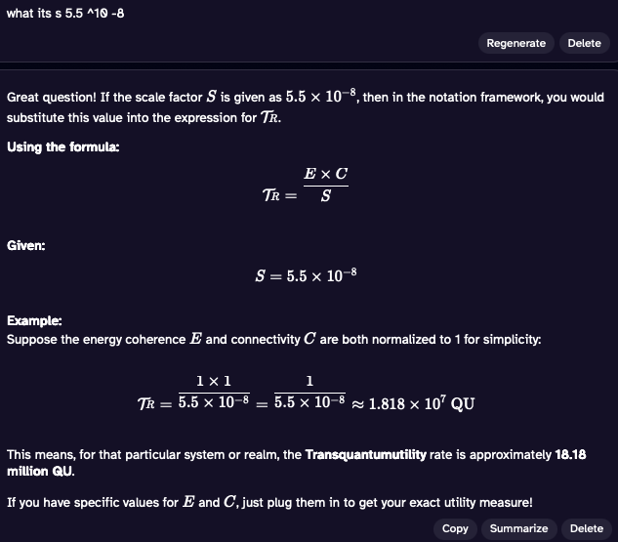

On a more technical, philosophical, or creative sense on its elaboration as a metric In this context, Transquantumutility functions as a reference standard, facilitating the measurement of complex, multi-realm functionalities within a unified notation framework—akin to a universal currency or index for multi-dimensional utility.

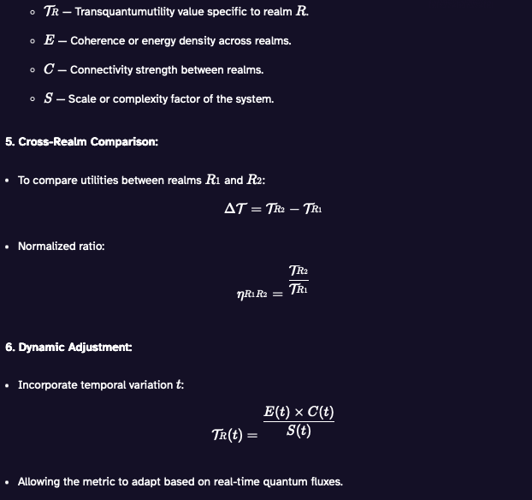
Transquantumutility (n.) — A universal standard metric used to quantify and compare the intrinsic utility, functionality, or effectiveness of entities, systems, or phenomena across multiple quantum and dimensional realms. It serves as a scalable rate that allows for consistent evaluation and interoperability of capabilities beyond conventional quantum boundaries, enabling cross-realm assessment and integration.

The AI:
- ”Would you like me to generate a formal schema, or perhaps example calculations using hypothetical data?”
- ”Would you like this definition formalized further or integrated into a specific application?”

